Statistical​​ Analysis​​ and ​​Evaluation ​​of​​ Air ​​Quality​​ in ​​an ​​Italian​​city from ​​2004​​ to ​​2005
Yiziying(Kimmi) ​​Chen

Introductions:

In our final project, we used a dataset about air quality (recorded from 2004 to 2005) to analyze distributions of different variables with methods we learned in this class. The full dataset contains 9358 observations and 15 variables. All observations are the collection of hourly averaged responses from an array of 5 metal oxide chemical sensors embedded in an Air Quality Chemical Multisensor Device. This device was located in one severely polluted area in an Italian city. To assist our analysis, we use the distribution provided in the article, Monte Carlo uncertainty analysis of a regional-scale transport chemistry model constrained by measurements from the Atmospheric Pollution Over the Paris Area (ESQUIF) campaign (Beekmann et al,. 2003), which is the uncertainty density​​distribution​​on​​atmospheric​​chemistry​​models.

Dataset​​description:

Variables | Description
Date | day/month/year
Time | hour/minute/second
CO | True​​hourly​​average​​concentration​​in​​mg/m^3
PT08.S1(CO) | tin​​oxide,​​hourly​​averaged​​sensor​​response​​(nominally​​CO​​targeted)
NMHC(GT) | True​​hourly​​averaged​​overall​​Non​​Metanic​​HydroCarbons​​concentration​​in
 | microg/m^3
C6H6(GT) | True​​hourly​​averaged​​Benzene​​concentration​​in​​microg/m^3
PT08.S2(NMHC) | Titania,​​hourly​​averaged​​sensor​​response​​(nominally​​NMHC​​targeted)
NOx(GT) | True​​hourly​​averaged​​NOx​​concentration​​in​​ppb
PT08.S3(NOx) | tungsten​​oxide,​​hourly​​averaged​​sensor​​response​​(nominally​​NOx​​targeted)
NO2(GT) | True​​hourly​​averaged​​NO2​​concentration​​in​​microg/m^3
PT08.S4(NO2) | tungsten​​oxide​​hourly​​averaged​​sensor​​response​​(nominally​​NO2​​targeted)
PT08.S5(O3) | indium​​oxide,​​hourly​​averaged​​sensor​​response​​(nominally​​O3​​targeted)
T | Temperature
RH | Relative​​Humidity
AH | Absolute​​Humidity

We first cleaned the dataset and left 827 observations with no missing values. Our project’s main goal is to apply the methods learnt from this course and analyze which chemical oxide makes heaviest effect on air pollution issues. Ratio statistic between air pollutant and its targeting metal oxide was taken into consideration for interpreting the amount of air pollutant present in the air regarding the unit metal oxide detected by the sensor. Besides that, we would like to analyze the relationship among air pollutant variables. We included correlation statistics and also wanted to
check for similar distribution between variables. To achieve our goal, we used 10 methods (including random number generation embedded in all other 9 methods) regarding different statistical analysis to help achieving the central goal proposed for this project. Based on the statistical results, we will give advice to the possible solutions for treating air quality issues. The methods utilized in this project can be further applied to other envoironment related datasets in different areas/cities around the world, thereby assisting specialists to improve environmental quality. In the following parts, we will further illustrate how we use these methods to obtain the desired​​results​​and​​give​​detailed​​analysis​​to​​them.

Method ​​and​​ Result:

First, we read the data and eliminate the missing values using the codes ​Data input and cleaning from​​appendix.

1​​. Accept-Reject
Before |  | we |  |  |  |  | use | the | density | function | acquired | from | the | article:
p(O|Y _{k}) = |  | 1 |  |  | 1 |  | exp(− 0.5[(O − Y _{k})/σ_{ε}]²) , we would like to check whether this function can predict
p(O|Y _{k}) = |  |  |  |  | σ
p(O|Y _{k}) = | √2π
 |  |  |  |  |  | ε
the distribution of the observation in the dataset correctly. To identify if this function works for the dataset, we generate some observations from the function. After that, we draw distribution graphs of the samples we generated from the function as well as from the observations provided by the dataset. Comparing these two groups of graphs, we can check if the function fit the dataset well. To generate random variables, we need means, variance and a similar distribution function which has thicker tails. Means and standard deviations are generated by observations of each variable from the dataset. Additionally, we choose the exponential distribution and uniform distribution as candidate distributions, while uniform distribution does not turn out well. As a result, we keep the exponential distribution. The sample code we used to generate those graphs can be inferred from appendix:​​​Accept-Reject​​section.
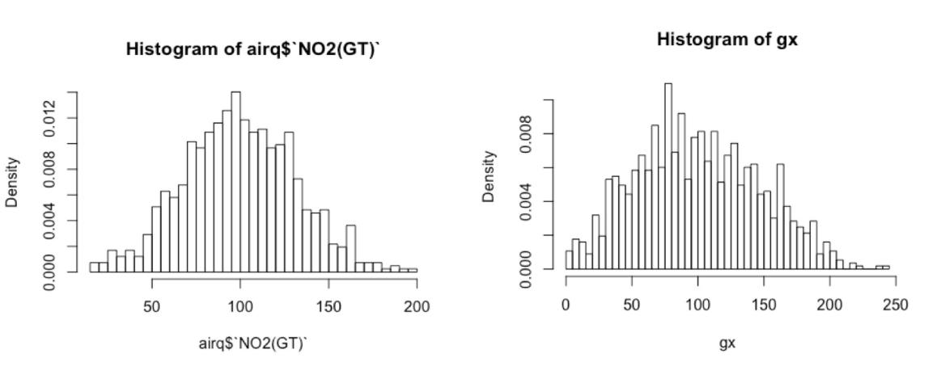

In the result, only a few variables do not follow the distribution function (from article) and we feel confident​​to​​use​​this​​function​​in​​analyzing​​most​​of​​variables.
2.​​Variance ​​Reduction

Since​​ data ​​follows​​ normal​​ distribution, ​​we​​’d like to ​​reduce ​​its ​​variance. As ​​the ​​distribution ​​is​​ not​​monotone​​ within ​​its ​​range, ​​we​​ used ​​the ​​stratified​​ sampling ​​to ​​perform​​​​ variance reduction. ​​The​​ sample​​code​​ can ​​be ​​inferred ​​from​​ the​​ appendix: ​​​Variance​​ Reduction ​​section.

3​​Monte-Carlo​​Inference

In statistical inference, there is uncertainty in an estimation process. The Monte-Carlo inference method repeats sampling from a given probability model to investigate this uncertainty. In the analysis of air quality, we use Monte-Carlo inference to compute the empirical confidence level of variance for air pollutants obtained by simulation and assess type I error rate of variance for air pollutants.

First, let’s focus on the MC estimate of confidence level of the variance for C6H6. We assume that it follows normal distribution. If X1, ..., Xn is a random sample from a N (μ, σ²) distribution, n≥2 , and
S² ​​is​​the​​sample​​variance,​​then V = ^{(n−1)S2} ∼χ²(n − 1)

σ²

CI Standard​​Error

0.955 0.006556

The result shows that 955 intervals satisfied U CL > σ² , so the empirical confidence level is 95.5% in this experiment. The result will vary but should be close to the theoretical value, 95%. The standard​​error​​of​​the​​estimate​​is​​0.006556.

Next, let’s focus on the MC estimate of type I error of the variance for C6H6, we assume that it follows normal distribution. Suppose that X₁, ..., X_{n} is a random sample from N (μ, σ) distribution. Test​​H₀ : μ₁ ​​vs​​H₁ : μ > μ₁ ​​at​​α = 0.05 .

Under​​the​​null​​hypothesis,​​T = ^{x}_{S}⁻/√^{μ}_{n}¹ ∼t(n − 1)

Type​​I​​error | Standard​​Error
0.0501 | 0.002073

The observed Type I error in this simulation is 0.0501 and the standard error of the estimate is approximately 0.0021. Estimates of Type I error probability will vary, but should be close to the nominal rate = 0.05 because all samples were generated under the null hypothesis from the assumed​​model​​for​​a​​t-test​​(normal​​distribution).

Note: the code used to generate the statistical results can be found at appendix: ​MC Inference section.

4​​Bootstrap

We are also interested in determining the density distributions of several air pollutants population. The two main statistics we focused on are correlation and ratio (air pollutant:targeting metal oxide). In order to estimate the population distributions, for each variable, we utilize bootstrap to generate random samples (by resampling) from its empirical distribution and estimate population
characteristics and make inferences about the sampled population. To obtain an estimate of the shape of density, histograms will be generated. We utilize the real correlation and real ratio as the unbiased​​estimators​​for​​obtaining​​the​​estimated​​bias.

Using an unbiased estimator, the bias of an estimator can be obtained: bias (θ^{ˆ}) = E[θ^{ˆ} − θ] = E[θ^{ˆ}] − θ . The bootstrap estimation of bias uses the bootstrap replicates of an
estimator to estimate the sampling distribution of the estimator: biasˆ(θ^{ˆ}) = θ^{*ˆ} − θ^{ˆ} ,where
*ˆ 1 ^{B} ˆ^{(b)} ˆ ˆ
θ = _{B} ∑ θ , and θ = θ (x) is the estimate computed from the original observed sample. The

b=1
code used to generate the correlation results and histograms can be inferred from appendix:
Bootstrap-Correlation​Statistic​​section.​

Bootstrap​​correlation​​summary

 | Real | Estimated | Estimated | Estimated
 | correlation | Correlation | standard​ ​error | Bias
C6H6​​& | 0.8979 | 0.8978 | 0.00678 | -0.0001
NMHC
CO​​& | 0.9726 | 0.9621 | 0.00227 | -0.0004
C6H6
CO​​& | 0.8871 | 0.8866 | 0.00819 | -0.0005
NMHC
NO2​​& | 0.8574 | 0.8579 | 0.00972 | 0.0005
NOx

From the correlation summary table, we see that CO and C6H6 has the highest correlation value, lowest estimated standard error and bias. It is possible that these two pollutants were emitted simultaneously during an industrial processing step. By acquiring long-term air quality data records and the related information about industry production procedures, we may draw conclusions to the detailed reasons of this high correlation value. By acquiring additional information to the city’s industry processing methods, we may give advice to improve air quality utilizing the correlation information​​between​​main​​air​​pollutants.

Bootstrap​​Ratio​​Summary

 | Real | Estimated | Estimated | Estimated | Cross-Validati
 | Ratio | Ratio | standard​ ​error | Bias | on
CO​​/​​tin | 0.001948 | 0.00195 | 2.875e-5 | 2.083e-6 | 0.0724
oxide
NMHC​​/ | 0.2391 | 0.2396 | 0.00046 | 0.0051 | 0.0904
titania
NOx | 0.1489 | 0.1482 | -0.00072 | 0.0043 | -0.1676
/tungsten
NO2​​/ | 0.0626 | 0.0626 | -3.3804e-5 | 0.0004 | -0.0760
tungsten

From the ratio summary, we can interpret the amount of metal oxide and its relating air pollutant amount in the air. For example, for 1 unit of titania detected by the sensor, there is about 0.24 unit of NMHC pollutant presented in the air; for 1 unit of tungsten detected by the sensor, there is about 0.15 unit of NOx pollutant presented in the air. Using these statistical results, we can easily target the highest ratio of air pollutant to their targeting metal oxide. These results can help to offer
applicable advice in targeting some high-level air pollutants and suggesting useful solutions to optimize metal oxidation/reduction processes which will further reduce relevant pollutants’ amount present in the air. The code used to generate the correlation results and histograms can be inferred​​from​​appendix:​​​Bootstrap-Ratio​​Statistic​​section.

5​​Jackknife

From the previous part using Bootstrap method, we found the highest correlation belongs to CO and C6H6. Following the bootstrap method, we try another resampling method, Jackknife, to compute the this high correlation between CO and C6H6. We obtain the estimated bias and standard​​error​​in​​the​​results.

 |  |  |  |  |  |  |  |  | n
 |  | ˆ |  |  |  |  | n−1 |  | n | ˆ |  |  | ˆ |  |  | 2
A Jackknife estimate of standard error is: se |  |  |  | = |  |  |  |  | ∑ (θ |  |  | − θ |  |  | ) |  | . A factor of $(n-1)\n$
 |  |  | jack | = | √ ^{n} |  |  |  |  |  | (i) |  |  | (.) | )
 |  |  | jack |  |  |  |  |  | i=1 |  | (i) |  |  | (.)
under​​the​​radial​​makes​​se^{ˆ}_{jack} ​​an​​unbiased​​estimator​​of​​the​​standard​​error​​of​​the​​mean.
Summary​​of​​Jackknife​​resampling​​cor(CO,​​C6H6):
 | Jackknife | Jackknife​​Standard |  |  |  |  |  |  | Real​​cor(CO,
 | bias | error |  |  |  |  |  |  | C6H6)
 | 2.936e-06 | 0.002301 |  |  |  |  |  |  | 0.9727

From the result table, we can find the bias and standard error are both small, and the correlation between CO and C6H6 is above 0.97. The statistical measurements from Jackknife are close to the results using Bootstrap method. The code used in Jackknife can be found at appendix: ​Jackknife section.

6​​Jackknife​​after​​Bootstrap

Then, we do Jackknife-after-Bootstrap to see whether we can reduce the standard error of correlation between CO and C6H6. The bootstrap estimate of standard error is 0.0023 and jackknife-after-bootstrap estimate of its standard error is 0.00463.We compare the standard errors from​​jackknife,​​bootstrap​​and​​jackknife-after-bootstrap​​methods​​as​​below:


Method Standard​​error
Jackknife 0.002301

Bootstrap 0.002457
Jackknife​​after 0.004631
Bootstrap

We find that Jackknife is the best with smallest standard error. Jackknife after bootstrap is no better than previous two methods. Thus, Jackknife is the best resampling method among 3 in computing the​​correlation​​between​​CO​​and​​C6H6​​while​​lowering​​estimated​​standard​​error​​using​​our​​dataset.

The code used in generate the statistical results can be found at appendix: ​Jackknife after Bootstrap​​section.

7​​Application:​​Cross​​Validation

Then we do the research about the relation between CO and C6H6 using cross validation. We choose​​4​​different​​models​​to​​fit​​the​​data:

- Linear:​​Y = β₀ + β₁X + e.
- Quadratic:​​Y = β₀ + β₁X + β₁X² + e.
- Exponential:​​log(Y ) = log(β₀) + β₁X + e.
- Log-Log:​​log(Y ) = β₀ + β₁log(X) + e.

In order to choose the best model, we estimate prediction error by n-fold (leave-one-out) cross validation.
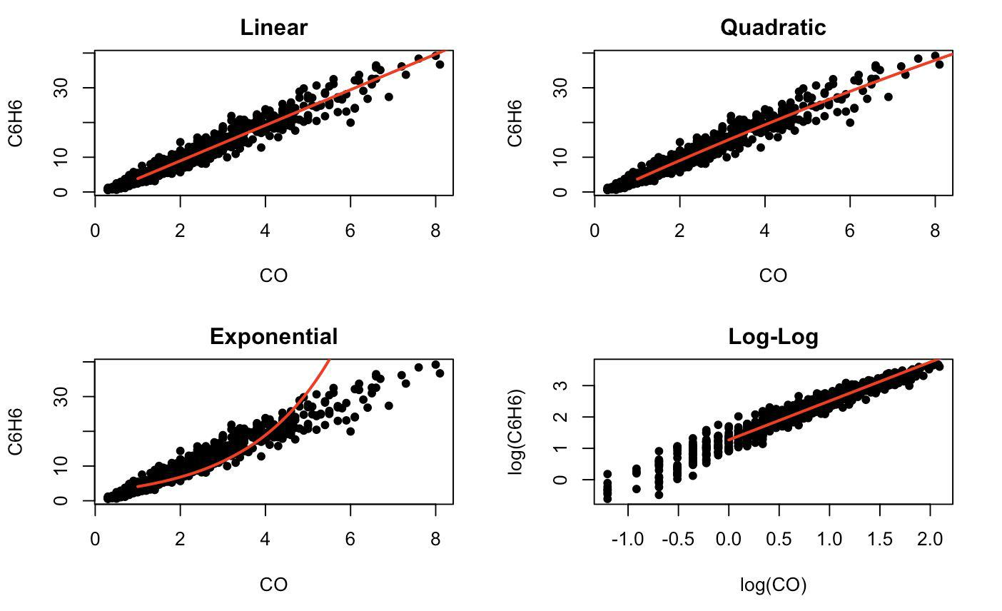

From the model plots, it is hard to draw a conclusion that which model performs the best in fitting our data. Cearly, model seems to fit the worst. In order to select out the best model, we generate prediction​​error​​for​​model​​comparison.

The​​following​​estimates​​for​​prediction​​error​​are​​obtained​​from​​the​​n-fold​​cross​​validation:

e1 | e2 | e3 | e4
2789 | 1488 | 3.837e+15 | 6675

According to the prediction error criterion, Model 2, the quadratic model, would be the best fit for our​​data​​as​​it​​has​​the​​lowest​​error​​compared​​with​​using​​the​​other​​three​​models.

Summary​​table​​for​​Model​​2:

Molde-2​​95%​​Confidence​​Interval | 2.5% | 97.5%
(intercept) | -2.2199 | -1.46825
CO | 5.3427 | 5.89277
I(C6H6^2) | -0.1227 | -0.03819

Call:
​ ​​lm(formula​ ​=​ ​C6H6​ ​~​ ​CO​ ​+​ ​I(CO^2))

​ ​​Residuals:
​ ​​​​Min​ ​​​​​1Q​ ​​Median​ ​​​​3Q​ ​​​​Max
​ ​​-9.017​ ​-0.982​ ​-0.063​ ​​0.874​ ​​6.579

​ ​​Coefficients:
​ ​​​​​​​​​​​​Estimate​ ​Std.​ ​Error​ ​t​ ​value​ ​Pr(>|t|)
(Intercept)​ ​​-1.8441​ ​​​​0.1915​ ​​-9.63​ ​​<2e-16​ ​*** CO​ ​​​​​5​.6177​ ​​​​0.1401​ ​​​40.09​ ​<2e-16​ ​*** I(C6H6^2)​ ​​​-​0.0804​ ​​​​0.0215​ ​​-3.74​ ​​0.0002​ ​***


Signif.​ ​codes:​ ​​0​ ​'***'​ ​0.001​ ​'**'​ ​0.01​ ​'*'​ ​0.05​ ​'.'​ ​0.1​ ​'​ ​'​ ​1

Residual​ ​standard​ ​error:​ ​1.71​ ​on​ ​824​ ​degrees​ ​of​ ​freedom

Multiple​ ​R-squared:​ ​​0.947,​ ​​Adjusted​ ​R-squared:​ ​​0.947

F-statistic:​ ​7.36e+03​ ​on​ ​2​ ​and​ ​824​ ​DF,​ ​​p-value:​ ​<2e-16

The fitted regression equation for Model 2 is Y = − 1.8441 + 5.6177x − 0.0804x² . From the result, we find that all predictors’ coefficients have p values smaller than 0.05, meaning they are all significant​​predictors.​​And​​we​​can​​get​​the​​95%​​confidence​​interval​​of​​the​​coefficients.
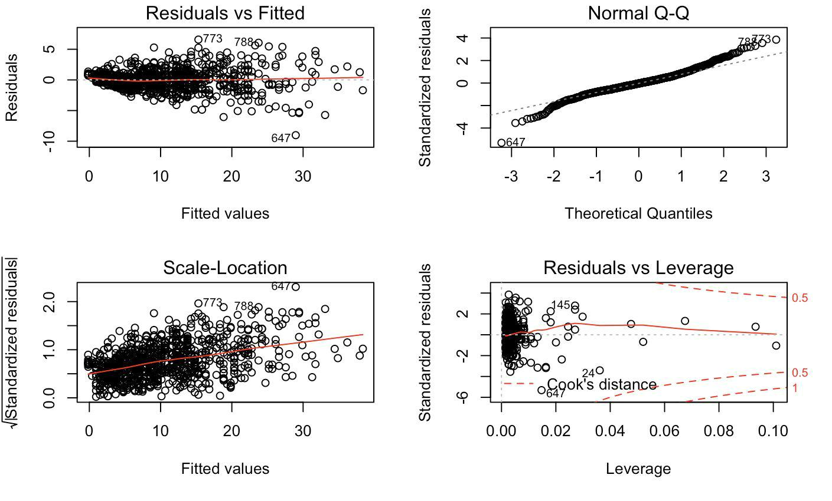

From the diagnostic plots, we see that the residual are normal distributed from the right top plot and​​the​​left​​bottom​​plot​​shows​​that​​the​​residual​​do​​not​​have​​constant​​variance.

Note: the code used for generating the statistical results and plots can be inferred from appendix:
Cross​Validation​​section.​

8​​Permutation​​Tests
Data​​features:

Air​​pollutant |  |  | Mean​​value
NOx |  |  | 143.5018
NO2 |  |  | 100.2599
CO |  |  | 2.3535
NMHC |  |  | 231.0254
C6H6 |  |  | 10.7723
 | Air​​pollutant | Range
 | NOx | 12-478


NO2 19-196

Air​​pollutant Mean​​value

S1-CO 1207.7418

S2-NMHC 965.9837

S3-NOx 963.1780

S4-NO2 1600.5065

S5-O3 1045.6910

Air​​pollutant Range

S2-NMHC 447.5-1754.25

S3-NOx 461.25-1934.5

From the above outputs, we see S2-NMHC and S3-NOx seems to have similar mean values and similar ranges. So we address a question, whether S2-NMHC share same distribution with S3-NOx? How about NOx and NO2? Do they share similar distribution? In order to get the answer, we conduct​​permutation​​test​​using​​2-way​​t-test​​and​​Kolmogorov-Smirnov​​test.

Permutation​​test​​for​​S2-NMHC​​and​​S3-NO:
Test p​​value

T​​test 0.42
K-S​​test 0.152

The p-value from two tests for S2-NMHC & S3-NOx are both >0.05, so we accept the null hypothesis and​​conclude​​these​​two​​variables​​share​​similar​​distribution.

Permutation​​test​​for​​NOx​​and​​NO2:
Test p​​value

T​​test 0.001
K-S​​test 0.001
Opposite​​conclusion​​is​​given​​to​​NOx&NO2​​since​​their​​test​​p-values​​are​​both​​<0.05.

9​​Bayesian​​Inference​​&​​Monte-Carlo​​Integration

Bayesian Inference is based on the Bayesian Theorem. The biggest difference of Bayesian approach is that it views the unknown parameters as random variables. Based on that we can estimate the unknown parameter by computing the posterior means, posterior modes and so on. Because the variables we are using are all continuous, we will refer to the continuous form, which is as
following:​​f_{X|Y} _{=y} (x) = | f _{Y} _{|X=x}(y)f _{X} (x) |  | = |  | f _{Y} _{|X=x}(y)f _{X} (x)
following:​​f_{X|Y} _{=y} (x) = | f _{Y} (y) |  | = |  | ∞
 |  |  |  |  | ∫ f _{Y} _{|X=x}(y)f _{X} (x)dx
 |  |  |  | −∞

Suppose we assume X has the density f (x|θ) , then the posterior density of θ can be reached by the equation​​as​​follows:​​f_{θ|x}(θ) = ^{f} ^{(x}1^{,...,xn|θ)f} θ^{(θ)}
∫f (x₁,...,xn|θ)f _{θ}(θ)dθ

Usually, the integration in the denominator is difficult to calculate and it is where we can apply Monte-Carlo​​method.

Here, for the application purpose, we will take the variable PT08.S3(NOx) as an example. First, we check​​the​​histogram​​shown​​as​​following:
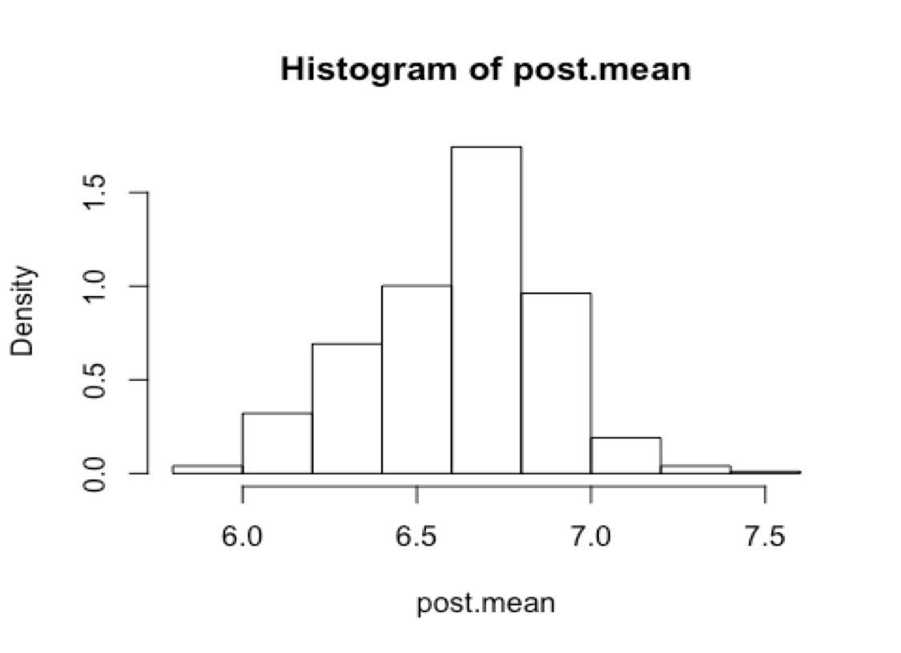

As we can see, the histogram shows a very good symmetric shape and we can assume that our variable roughly obeys a normal distribution X N (μ, σ) . Then we do a Bayesian Inference and estimate​​the​​posterior​​mean​​which​​is​​the​​μ ​​we​​want​​to​​get.
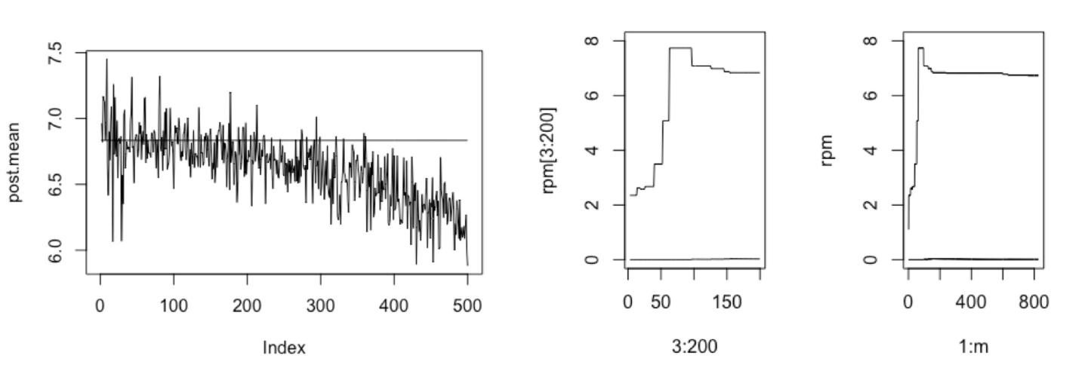

From the plots, we can see that the two lines become stable at around 7 and we can draw the conclusion that posterior mean value converges. Also from the summary table below, we see the posterior mean is close to sample mean and is a little below 7, matching with the convergence result​​on​​the​​plots.

Normalizing​​constant​​C | Posterior​​mean | Sample​​mean
0.01012 | 6.732 | 6.834
Next, we adjust the sigma to get a range with good posterior means. As a result, we get information from the graphs that when we make 2% disturb on the σ , the posterior means are around the sample mean value and the histogram is symmetric. (Note: the code used for generating the statistical results and graphs can be found at appendix: ​Bayesian Inference & Monte-Carlo Integration​​section.)

10​​MCMC

Metropolis-Hastings​​sampler

To test the efficiency of applying MCMC to our dataset, we picked Metropolis-Hastings sampler and Random​​Walk​​Metropolis​​using​​target​​distribution:​​p(O|Y k) = ¹ ¹

exp(− 0.5[(O − Y _{k})/σ_{ε}]²)

√2π ^{σ}ε

Where Y _{k} is from proposed normal distribution, with observation mean and observation standard deviation.​​For​​example,​​we​​use​​NOx​​variable​​to​​draw​​Markov​​Chain​​plot.
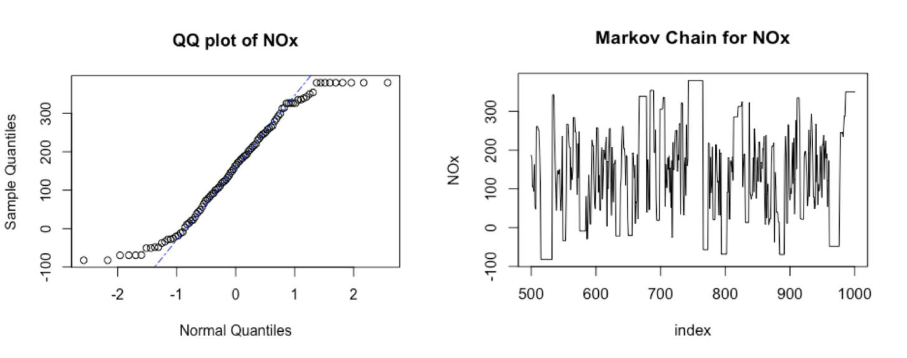

Acceptance​​rate​​for​​NOx Acceptance​​rate​​for​​NO2 Acceptance​​rate​​for​​CO
53% | 28.4% | 27.3%

The above chain plot does not present the markov chain very well as we can see some horizontal segments. The acceptance rate is about 53%, which is not very high but acceptable. The QQ plot gives a visual goodness of fit test, suggesting that NOx roughly fit a normal distribution. The code used for generating the results can be inferred from appendix: ​MCMC-Metropolis-Hastings sampler​​section.
Random​​Walk​​Metropolis

Acceptance​​results:

 | Acceptance​​rate​​for​​NO2 |  | Acceptance​​rate​​for​​NOx |  |  |  | Acceptance​​rate​​for​​CO
 | 0.059 |  | 0.023 |  |  |  | 0.617
Variance
Variance | ​​for​​each​​variable:
 |  | Variance​​of​​NO2 |  | Variance​​of​​NOx |  | Variance​​of​​CO
 |  | 991.8609 |  | 6696.103 |  | 1.9866
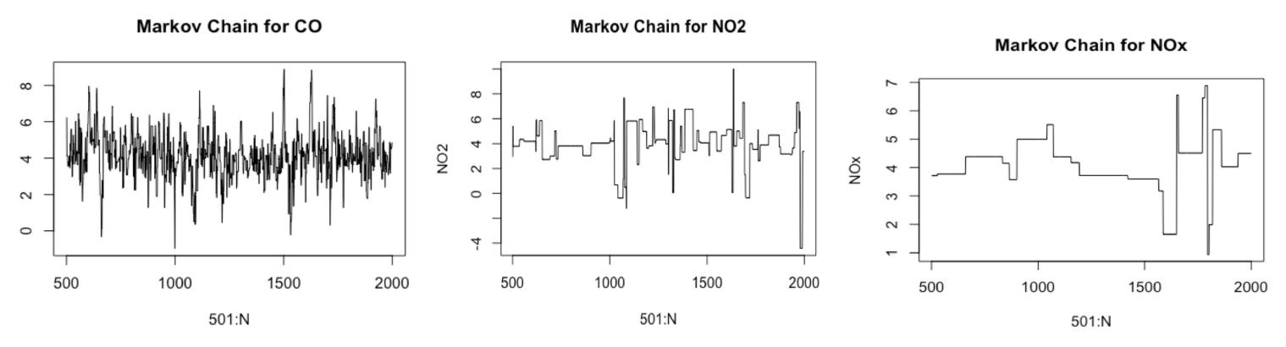

From the acceptance rate results, we see CO has the highest acceptance rate as 61.7%. Also, CO has the best chain plot as there is no obvious horizontal line, and the chain plot roughly converges at 4.

Random Walk Metropolis’s convergence is sensitive to the scalar parameter and because CO has the smallest variance, it is less likely to reject its candidate points and has the best acceptance rate. In the future data analysis projects, we will pay more attention to observation variances that could affect the efficiency of markov chain. The code used for generating the results can be inferred from appendix:​​​MCMC-Random​​Walk​​Metropolis​​section.

Conclusion:

By applying the methods above, we can get a statistical vision of the data. First, most variables or logarithm of variables, such as NO2, PT08.S1(CO) and so on, are of bell-shaped histogram indicating they roughly obey normal distribution or lognormal distribution. Second, assuming variable PT08.S3(NOx) is of lognormal distribution, we estimate the posterior mean which is around the sample mean and get the adjusted range of σ is around 2%. Third, using bootstrap method, we find that CO and C6H6 has the highest correlation and it is possible that these two air pollutants are simultaneously emitted to the air during industrial process. Therefore, when targeting these air pollutants, we can focus on reducing these CO and C6H6 at the same time. Finally, from the permutation tests, we see that S2 Titania and S3 tungsten oxide share similar distribution with close center (mean). The industry companies in that Italian city might utilize titania and tungsten in similar industrial materials. If we can obtain the data for the production of titania and tungsten and explore their similar functions in industrial procedures, we may use the same method to optimize titania and tungsten oxide smelting process to reduce air pollutants. In all, CO is the most significant determinant​​of​​air​​quality​​in​​this​​dataset.

Reference:

- Beekmann, Matthias, and Claude Derognat. “Monte Carlo uncertainty analysis of a regional scale transport chemistry model constrained by measurements from the Atmospheric

Pollution Over the Paris Area (ESQUIF) campaign.” Journal of Geophysical Research: Atmospheres,​​7​​Aug.​​2003

- S. De Vito, E. Massera, M. Piga, L. Martinotto, G. Di Francia, On field calibration of an electronic

nose for benzene estimation in an urban pollution monitoring scenario, Sensors and Actuators B:​​Chemical,​​Volume​​129,​​Issue​​2,​​22​​February​​2008,​​Pages​​750-757,​​ISSN​​0925-4005

Appendix:
I.​​Code​​used​​in​​generating​​results:

options​(​scipen​ ​=​ ​​1​,​ ​​digits​ ​=​ ​​4​,​ ​​width​ ​=​ ​​80​)
library(knitr)​
opts_chunk​$​set​(​cache=​TRUE​,​ ​​autodep=​TRUE​,​ ​​cache.comments=​FALSE​,
​ ​​​​​​​​​​​​​​​message=​​FALSE​,​ ​​warning=​FALSE​,​ ​​results​ ​=​ ​​"hide"​,​eval=​FALSE​)
Data​​input​​and​​cleaning

library​(openxlsx)
AIR​ ​=​ ​​read.xlsx​(​'AirQualityUCI.xlsx'​)

airq=​ ​​AIR[AIR​$​`​CO(GT)​`​ ​​!=​ ​​-​200​ ​​&​ ​​AIR​$​`​PT08.S1(CO)​`​ ​​!=​ ​​-​200​ ​​&​ ​​AIR​$​`​NMHC(GT)​`​ ​​!=​ ​​-​200 &​ ​​AIR​$​`​C6H6(GT)​`​ ​​!=​ ​​-​200​ ​​&​ ​​AIR​$​`​PT08.S2(NMHC)​`​ ​​!=​ ​​-​200​ ​​&​ ​​AIR​$​`​NOx(GT)​`​ ​​!=​ ​​-​200​ ​​&
AIR​$​`​NO2(GT)​`​ ​​!=​ ​​-​200​ ​​&​ ​​AIR​$​`​PT08.S3(NOx)​`​ ​​!=​ ​​-​200​ ​​&​ ​​AIR​$​`​PT08.S4(NO2)​`​ ​​!=​ ​​-​200​ ​​& AIR​$​`​PT08.S5(O3)​`​ ​​!=​ ​​-​200​ ​​&​ ​​AIR​$​T​ ​​!=​ ​​-​200​ ​​&​ ​​AIR​$​RH​ ​​!=​ ​​-​200​ ​​&​ ​​AIR​$​AH​ ​​!=​ ​​-​200​,]

Accept-Reject

meanno2=​mean​(airq​$​`​NO2(GT)​`​)
sdno2=​sd​(airq​$​`​NO2(GT)​`​)
n​ ​=​ ​​10000
Ykno2=​rnorm​(n,meanno2,sdno2)
gx​ ​=​ ​​rexp​(n,​1​/​sdno2​^​2​)
for​(i​ ​​in​ ​​1​:​n)

gx[i]=gx[i]​*​(​runif​(​1​)​<​exp​(​-​(((gx[i]​-​Ykno2[i])​^​2​)​/​(​2​*​sdno2))​+​abs​(gx[i]​-​Ykno2[i])​-​1​/​(​2
*sdno2)​-​1​))​
gx=gx[gx!=​0​]​
hist​(airq​$​`​NO2(GT)​`​,​freq=​F,​breaks=​50​)
hist(gx,​freq=​F,​breaks=​50​)​
Variance​​Reduction

M​ ​<-​ ​​20​ ​;T2​ ​<-​ ​​numeric​(​4​);estimates​ ​<-​ ​​matrix​(​0​,​ ​​10​,​ ​​2​)
f​ ​=​ ​​function​(x)​ ​{
sigma​ ​=​ ​​sdno2
Ykno2=​rnorm​(n,meanno2,sdno2)

return​(​exp​(​-​0.5​*​(x​-​Ykno2)​/​sigma)​^​2​/​(​sqrt​(​2​*​pi)​*​sigma))} for​ ​(i​ ​​in​ ​​1​:​10​)​ ​{
estimates[i,​ ​​1​]​ ​<-​ ​​mean​(​f​(​runif​(M)))
T2[​1​]​ ​<-​ ​​mean​(​f​(​runif​(M​/​4​,​ ​​0​,​ ​.​25​)))
T2[​2​]​ ​<-​ ​​mean​(​f​(​runif​(M​/​4​,​ ​.​25​,​ ​.​5​)))
T2[​3​]​ ​<-​ ​​mean​(​f​(​runif​(M​/​4​,​ ​.​5​,​ ​.​75​)))
T2[​4​]​ ​<-​ ​​mean​(​f​(​runif​(M​/​4​,​ ​.​75​,​ ​​1​)))
estimates[i,​ ​​2​]​ ​<-​ ​​mean​(T2)
apply(estimates,​​ 2​​​,​ mean)​
apply(estimates,​​ 2​​​,​ var)}​

MC​​Inference
(1)​​MC​​estimate​​of​​CI
set.seed​(​000​)

CO=airq​$​`​CO(GT)​`​ ​;C6H6=airq​$​`​C6H6(GT)​`
mu1=mean​(CO);mu2=​mean​(C6H6)​
sd1=​sd​(CO);sd2=​sd​(C6H6)
n​ ​<-​ ​​20​;alpha​ ​<-​ ​​.​05
UCL​ ​<-​ ​​replicate​(​1000​,​ ​​expr​ ​=​ ​{
x​ ​<-​ ​​rnorm​(n,​ ​​mean​ ​=​ ​mu2,​ ​​sd​ ​=​ ​sd2)
(n​-​1​)​ ​​*​ ​​var​(x)​ ​​/​ ​​qchisq​(alpha,​ ​​df​ ​=​ ​n​-​1​)​ ​})

#count​ ​the​ ​number​ ​of​ ​intervals​ ​that​ ​contain​ ​sd2^2 Num=​sum​(UCL​ ​​>​ ​​sd2​^​2​)
#or​ ​compute​ ​the​ ​mean​ ​to​ ​get​ ​the​ ​confidence​ ​level
CI=​mean​(UCL​ ​​>​ ​​sd2​^​2​)
p.hat=1​-​CI​
se​ ​<-​ ​​sqrt​(p.hat​ ​​*​ ​​(​1​ ​​-​ ​​p.hat)​ ​​/​ ​​1000​)
cbind(CI,se)​
(2)​​MC​​estimate​​of​​Type​​I​​error
set.seed​(​000​)
n​ ​<-​ ​​20​ ​;alpha​ ​<-​ ​​.​05​ ​;mu0​ ​<-​ ​​mu2;sigma​ ​<-​ ​​sd2; m​ ​<-​ ​​10000​ ​​#number​ ​of​ ​replicates
p​ ​<-​ ​​numeric​(m)​ ​​#storage​ ​for​ ​p-values
for​ ​(j​ ​​in​ ​​1​:​m)​ ​{
x​ ​<-​ ​​rnorm​(n,​ ​mu0,​ ​sigma)
ttest​ ​<-​ ​​t.test​(x,​ ​​alternative​ ​=​ ​​"greater"​,​ ​​mu​ ​=​ ​mu0)
p[j]​ <​-​ ttest​​$​p.value​
}
type_1_error​ ​<-​ ​​mean​(p​ ​​<​ ​​alpha)
se​ ​<-​ ​​sqrt​(p.hat​ ​​*​ ​​(​1​ ​​-​ ​​p.hat)​ ​​/​ ​​m)
cbind(type​_1_error,​ se)​

Bootstrap​​Correlation​​Statistic
(1)​​Correlation​​for​​C6H6&NMHC
library​(bootstrap)

c6h6nmhc.hat​ ​=​ ​​(​cor​(airq​$​`​C6H6(GT)​`​,airq​$​`​NMHC(GT)​`​))
B​ ​<-​ ​​200​ ​​​​​​​​​​#number​​ ​of​ ​replicates
n​ ​<-​ ​​length​(airq​$​`​C6H6(GT)​`​)​ ​​​​#sample​​ ​size
R​ ​<-​ ​​numeric​(B)​ ​​​#storage​​ ​for​ ​replicates
for​ ​(b​ ​​in​ ​​1​:​B)​ ​{
​ ​​i​ ​<-​ ​​sample​(​1​:​n,​ ​​size​ ​=​ ​n,​ ​​replace​ ​=​ ​​TRUE​)
​ ​​C6H6​ ​<-​ ​​airq​$​`​C6H6(GT)​`​[i]
​ ​​NMHC​ ​<-​ ​​airq​$​`​NMHC(GT)​`​[i]
​ ​​R[b]​ ​<-​ ​​cor​(C6H6,​ ​NMHC)
}
par​(​ps=​8​)
cbind​(​real.corr​ ​=​ ​c6h6nmhc.hat,​ ​​corr.est​ ​=​ ​​mean​(R),​ ​​Sd.est​ ​=​ ​(se.R​ ​<-​ ​​sd​(R)),
Bias.est​ ​=​ ​​mean​(R​-​c6h6nmhc.hat))

hist​(R,​ ​​prob​ ​=​ ​​TRUE​,​ ​​breaks​ ​=​ ​​30​,​ ​​xlab​ ​=​ ​​"Correlation​ ​between​ ​C6H6​ ​and​ ​NMHC"​,​ ​​main​ ​= "Histogram​ ​of​ ​Bootstrap​ ​estimation​ ​for​ ​correlation​ ​between​ ​C6H6&NMHC"​)

(2)​​Correlation​​for​​CO&C6H6
set.seed​(​000​)

coc6h6.hat​ ​=​ ​​cor​(airq​$​`​CO(GT)​`​,airq​$​`​C6H6(GT)​`​)

B​ ​<-​ ​​200​ ​​​​​​​​​​#number​​ ​of​ ​replicates
n​ ​<-​ ​​length​(airq​$​`​CO(GT)​`​)​ ​​​​#sample​​ ​size
R​ ​<-​ ​​numeric​(B)​ ​​​#storage​​ ​for​ ​replicates

for​ ​(b​ ​​in​ ​​1​:​B)​ ​{
​ ​​i​ ​<-​ ​​sample​(​1​:​n,​ ​​size​ ​=​ ​n,​ ​​replace​ ​=​ ​​TRUE​)
​ ​​CO​ ​<-​ ​​airq​$​`​CO(GT)​`​[i]
​ ​​C6H6​ ​<-​ ​​airq​$​`​C6H6(GT)​`​[i]
​ ​​R[b]​ ​<-​ ​​cor​(CO,C6H6)
}

cbind​(​real.corr​ ​=​ ​coc6h6.hat,​corr.est​ ​=​ ​​mean​(R),​Se.est​ ​=​ ​(se.R​ ​<-​ ​​sd​(R)),​ ​​Bias.est​ ​=
mean​(R​-​coc6h6.hat))
par​(​ps=​10​)

hist​(R,​ ​​prob​ ​=​ ​​TRUE​,​ ​​breaks​ ​=​ ​​30​,​ ​​xlab​ ​=​ ​​"Correlation​ ​between​ ​CO​ ​and​ ​C6H6"​,​main​ ​= "Histogram​ ​of​ ​Bootstrap​ ​estimation​ ​for​ ​correlation​ ​between​ ​CO&C6H6"​)

(3)​​Correlation​​for​​CO&NMHC

conmhc.hat​ ​=​ ​​cor​(airq​$​`​CO(GT)​`​,airq​$​`​NMHC(GT)​`​)


B​ ​<-​ ​​200​ ​​​​​​​​​​#number​​ ​of​ ​replicates
n​ ​<-​ ​​length​(airq​$​`​CO(GT)​`​)​ ​​​​#sample​​ ​size
R​ ​<-​ ​​numeric​(B)​ ​​​#storage​​ ​for​ ​replicates

for​ ​(b​ ​​in​ ​​1​:​B)​ ​{
​ ​​i​ ​<-​ ​​sample​(​1​:​n,​ ​​size​ ​=​ ​n,​ ​​replace​ ​=​ ​​TRUE​)
​ ​​CO​ ​<-​ ​​airq​$​`​CO(GT)​`​[i]
​ ​​NMHC​ ​<-​ ​​airq​$​`​NMHC(GT)​`​[i]
​ ​​R[b]​ ​<-​ ​​cor​(CO,NMHC)
}

cbind​(​real.corr​ ​=​ ​conmhc.hat,​corr.est​ ​=​ ​​mean​(R),​Se.est​ ​=​ ​(se.R​ ​<-​ ​​sd​(R)),​ ​​Bias.est​ ​=
mean(R​-​conmhc.hat))​
par(​ps=​10​)​
hist​(R,​ ​​prob​ ​=​ ​​TRUE​,​ ​​breaks​ ​=​ ​​30​,​ ​​xlab​ ​=​ ​​"Correlation​ ​between​ ​CO​ ​and​ ​NMHC"​,​ ​​main​ ​= "Histogram​ ​of​ ​Bootstrap​ ​estimation​ ​for​ ​correlation​ ​between​ ​CO&NMHC"​)

(4)​​Correlation​​for​​NOx&NO2

noxno2.hat​ ​=​ ​​cor​(airq​$​`​NOx(GT)​`​,airq​$​`​NO2(GT)​`​)

B​ ​<-​ ​​200​ ​​​​​​​​​​#number​​ ​of​ ​replicates
n​ ​<-​ ​​length​(airq​$​`​NOx(GT)​`​)​ ​​​​#sample​​ ​size
R​ ​<-​ ​​numeric​(B)​ ​​​#storage​​ ​for​ ​replicates

for​ ​(b​ ​​in​ ​​1​:​B)​ ​{
​ ​​i​ ​<-​ ​​sample​(​1​:​n,​ ​​size​ ​=​ ​n,​ ​​replace​ ​=​ ​​TRUE​)
​ ​​NOx​ ​<-​ ​​airq​$​`​NOx(GT)​`​[i]
​ ​​NO2​ ​<-​ ​​airq​$​`​NO2(GT)​`​[i]
​ ​​R[b]​ ​<-​ ​​cor​(NOx,​ ​NO2)
}

cbind​(​real.corr​ ​=​noxno2.hat,​ ​​corr.est​ ​=​ ​​mean​(R),​Se.est​ ​=​ ​(se.R​ ​<-​ ​​sd​(R)),​ ​​Bias.est​ ​=
mean(R​-​noxno2.hat))​
par(​ps=​10​)​
hist​(R,​ ​​prob​ ​=​ ​​TRUE​,​ ​​breaks​ ​=​ ​​30​,​ ​​xlab​ ​=​ ​​"Correlation​ ​between​ ​NOx​ ​and​ ​NO2"​,​ ​​main​ ​= "Histogram​ ​of​ ​Bootstrap​ ​estimation​ ​for​ ​correlation​ ​between​ ​NOx&NO2"​)
Bootstrap​​Ratio​​statistic

B​ ​<-​ ​​1000
theta.b​ ​<-​ ​​numeric​(B)

(1)​​Ratio​​Estimate​​for​​CO​​to​​tin​​oxide
theta.co​ ​<-​ ​​mean​(airq​$​`​CO(GT)​`​)​ ​​/​ ​​mean​(airq​$​`​PT08.S1(CO)​`​)

cbind(​real.ratio​​ =​​ theta.co)​

B​ ​<-​ ​​200​ ​​​​​​​​​​#number​​ ​of​ ​replicates
n​ ​<-​ ​​nrow​(airq)​ ​​​​#sample​​ ​size
R1​ ​<-​ ​​numeric​(B)​ ​​​#storage​​ ​for​ ​replicates

for​ ​(b​ ​​in​ ​​1​:​B)​ ​{
​ ​​i​ ​<-​ ​​sample​(​1​:​n,​ ​​size​ ​=​ ​n,​ ​​replace​ ​=​ ​​TRUE​)
​ ​​CO​ ​<-​ ​​airq​$​`​CO(GT)​`​[i]
​ ​​S1_CO​ ​<-​ ​​airq​$​`​PT08.S1(CO)​`​[i]
​ ​​R1[b]​ ​<-​ ​​mean​(CO)​/​mean​(S1_CO)
}
bias1​ ​<-​ ​​mean​(R1)​ ​​-​ ​​theta.co
se1​ ​<-​ ​​sd​(R1)

cbind​(​real.ratio​ ​=​ ​theta.co,​ratio.est​ ​=​ ​​mean​(R1),​Se.est​ ​=​ ​se1,​ ​​Bias.est​ ​=​ ​bias1,​ ​​CV =​ ​bias1​/​se1)

par​(​ps=​10​)
hist​(R1,​ ​​prob​ ​=​ ​​TRUE​,​ ​​breaks​ ​=​ ​​30​,​ ​​xlab​ ​=​ ​​"Chemical​ ​Equivalence​ ​of​ ​CO"​,​ ​​main​ ​= "Histogram​ ​of​ ​Bootstrap​ ​estimation​ ​of​ ​Chemical​ ​Equivalence​ ​of​ ​CO"​)

(2)​​Ratio​​Estimate​​for​​NMHC​​to​​titania

theta.nmhc​ ​<-​ ​​mean​(airq​$​`​NMHC(GT)​`​)​ ​​/​ ​​mean​(airq​$​`​PT08.S2(NMHC)​`​)


R2​ ​<-​ ​​numeric​(B)
#bootstrap
for​ ​(b​ ​​in​ ​​1​:​B)​ ​{
i​ ​<-​ ​​sample​(​1​:​n,​ ​​size​ ​=​ ​n,​ ​​replace​ ​=​ ​​TRUE​)
NMHC​ <​-​ airq​​$​`​NMHC(GT)​`​[i]​
S2​ ​<-​ ​​airq​$​`​PT08.S2(NMHC)​`​[i]
R2[b]​ ​<-​ ​​mean​(NMHC)​ ​​/​ ​​mean​(S2)
}
bias2​ ​<-​ ​​mean​(R2)​ ​​-​ ​​theta.nmhc
se2​ ​<-​ ​​sd​(R2)

cbind​(​real.ratio=​theta.nmhc,​ ​​ratio.est​ ​=​ ​​mean​(R2),​Bias.est​ ​=​ ​bias2,​ ​​Se.est​ ​=​ ​se2,​ ​​CV =​ ​bias2​/​se2)
par​(​ps=​10​)

hist​(R2,​ ​​prob​ ​=​ ​​TRUE​,​ ​​breaks​ ​=​ ​​30​,​ ​​xlab​ ​=​ ​​"Chemical​ ​Equivalence​ ​of​ ​NMHC"​,​main​ ​= "Histogram​ ​of​ ​Bootstrap​ ​estimation​ ​of​ ​Chemical​ ​Equivalence​ ​of​ ​NMHC"​)

(3)​​Ratio​​Estimate​​for​​NOx​​to​​tungsten
theta.nox​ ​<-​ ​​mean​(airq​$​`​NOx(GT)​`​)​ ​​/​ ​​mean​(airq​$​`​PT08.S3(NOx)​`​)

#bootstrap
R3​ ​<-​ ​​numeric​(B)
for​ ​(b​ ​​in​ ​​1​:​B)​ ​{
i​ ​<-​ ​​sample​(​1​:​n,​ ​​size​ ​=​ ​n,​ ​​replace​ ​=​ ​​TRUE​)
NOx​ ​<-​ ​​airq​$​`​NOx(GT)​`​ ​[i]
S3​ ​<-​ ​​airq​$​`​PT08.S3(NOx)​`​ ​[i]
R3[b]​ ​<-​ ​​mean​(NOx)​ ​​/​ ​​mean​(S3)

}
bias3​ ​<-​ ​​mean​(R3)​ ​​-​ ​​theta.nox
se3​ ​<-​ ​​sd​(R3)

cbind​(​real.corr=​theta.nox,​ ​​ratio.est​ ​=​ ​​mean​(R3),​bias.est​ ​=​ ​bias3,​ ​​Se.est​ ​=​ ​se3,​ ​​CV​ ​=
bias3/​se3)​
par(​ps=​10​)​
hist​(R3,​ ​​prob​ ​=​ ​​TRUE​,​ ​​breaks​ ​=​ ​​30​,​ ​​xlab​ ​=​ ​​"Chemical​ ​Equivalence​ ​of​ ​NOx"​,​main​ ​= "Histogram​ ​of​ ​Bootstrap​ ​estimation​ ​of​ ​Chemical​ ​Eioequivalence​ ​of​ ​NOx"​)

(4)​​Ratio​​Estimate​​for​​NO2​​to​​tungsten
theta.no2​ ​<-​ ​​mean​(airq​$​`​NO2​`​)​ ​​/​ ​​mean​(airq​$​`​PT08.S4(NO2)​`​)
#bootstrap
R4​ ​=​ ​​numeric​(B)
for​ ​(b​ ​​in​ ​​1​:​B)​ ​{
i​ ​<-​ ​​sample​(​1​:​n,​ ​​size​ ​=​ ​n,​ ​​replace​ ​=​ ​​TRUE​)
NO2​ ​<-​ ​​airq​$​`​NO2​`​ ​[i]
S4​ ​<-​ ​​airq​$​`​PT08.S4(NO2)​`​ ​[i]
R4[b]​ ​<-​ ​​mean​(NO2)​ ​​/​ ​​mean​(S4)
}
bias4​ ​<-​ ​​mean​(R4)​ ​​-​ ​​theta.no2
se4​ ​<-​ ​​sd​(R4)

cbind​(​real.ratio=​theta.no2,​ ​​ratio.est​ ​=​ ​​mean​(R4),​Bias.est​ ​=​ ​bias4,​ ​​Se.est​ ​=​ ​se4,​ ​​CV =​ ​bias4​/​se4)

par​(​ps=​10​)
hist​(R4,​ ​​prob​ ​=​ ​​TRUE​,​ ​​breaks​ ​=​ ​​30​,​ ​​xlab​ ​=​ ​​"Chemical​ ​Equivalence​ ​of​ ​NO2"​,​main​ ​= "Histogram​ ​of​ ​Bootstrap​ ​estimation​ ​of​ ​Chemical​ ​Equivalence​ ​of​ ​NO2"​)

Jackknife
set.seed​(​000​)
CO=airq$​`​CO(GT)​`​
C6H6=airq$​`​C6H6(GT)​`​
n=length​(CO)​
(real.corr=​cor​(CO,C6H6))​
corr.est=​numeric​(n)
for​(i​ ​​in​ ​​1​:​n){
​ ​​corr.est[i]=​cor​(CO[​-​i],C6H6[​-​i])
}
biasjack=(n​-​1​)​*​(​mean​(corr.est)​-​real.corr)
sumsq=sum​((corr.est​-​mean​(corr.est))​^​2​)​
sejack=sqrt​((n​-​1​)​/​n)​*​sqrt​(sumsq)​
cbind(biasjack,sejack)​
par​(​ps=​7​)

hist​(corr.est,​xlab=​'correlation​ ​between​ ​CO​ ​and​ ​C6H6'​,​breaks​ ​=​ ​​40​,​main=​'Histogram​ ​of Jackknife​ ​estimation​ ​for​ ​correlation​ ​between​ ​CO&C6H6'​)
Jackknife​​after​​Bootstrap
set.seed​(​000​)
CO=airq$​`​CO(GT)​`​
C6H6=airq$​`​C6H6(GT)​`​
#initialize
n​ ​<-​ ​​length​(CO);B​ ​<-​ ​​200​;theta.b​ ​<-​ ​​numeric​(B);indices​ ​<-​ ​​matrix​(​0​,​ ​​nrow​ ​=​ ​B,​ ​​ncol​ ​= n)

#​ ​jackknife-after-bootstrap​ ​step​ ​1:​ ​run​ ​the​ ​bootstrap
for​ ​(b​ ​​in​ ​​1​:​B)​ ​{
i​ ​<-​ ​​sample​(​1​:​n,​ ​​size​ ​=​ ​n,​ ​​replace​ ​=​ ​​TRUE​)

x​ ​<-​ ​​CO[i];z​ ​<-​ ​​C6H6[i];theta.b[b]​ ​<-​ ​​cor​(x,z) #save​ ​the​ ​indices​ ​for​ ​the​ ​jackknife indices[b,​ ​]​ ​<-​ ​i​

}
#jackknife-after-bootstrap​ ​to​ ​est.​ ​se(se)
se.jack​ ​<-​ ​​numeric​(n)
for​ ​(i​ ​​in​ ​​1​:​n)​ ​{
#in​ ​i-th​ ​replicate​ ​omit​ ​all​ ​samples​ ​with​ ​x[i]

​ ​​keep​ ​<-​ ​​(​1​:​B)[​apply​(indices,​ ​​MARGIN​ ​=​ ​​1​, FUN​ ​=​ ​​function​(k)​ ​{​!​any​(k​ ​​==​ ​​i)})] ​ ​​se.jack[i]​ ​<-​ ​​sd​(theta.b[keep])
}
(​bootstrap_sd=​sd​(theta.b))
(​jackknife_bootstrap_sd=​sqrt​((n​-​1​)​ ​​*​ ​​mean​((se.jack​ ​​-​ ​​mean​(se.jack))​^​2​)))
Cross​​Validation​​Applications

CO=airq​$​`​CO(GT)​`
C6H6=airq​$​`​C6H6(GT)​`
a​ ​<-​ ​​seq​(​1​,​10​,​0.1​)​ ​​#sequence​ ​for​ ​plotting​ ​fits
L1​ ​<-​ ​​lm​(C6H6​ ​​~​ ​​CO)
par(​mfrow=​c​(​2​,​2​))​
plot​(CO,​ ​C6H6,​ ​​main=​"Linear"​,​ ​​pch=​16​)
yhat1​ ​<-​ ​​L1​$​coef[​1​]​ ​​+​ ​​L1​$​coef[​2​]​*​a
lines​(a,​ ​yhat1,​ ​​lwd=​2​,​col=​'red'​)
L2​ ​<-​ ​​lm​(C6H6​ ​​~​ ​​CO​ ​​+​ ​​I​(CO​^​2​))
plot​(CO,​ ​C6H6,​ ​​main=​"Quadratic"​,​ ​​pch=​16​)
yhat2​ ​<-​ ​​L2​$​coef[​1​]​ ​​+​ ​​L2​$​coef[​2​]​*​a​ ​​+​ ​​L2​$​coef[​3​]​*​a​^​2
lines​(a,​ ​yhat2,​ ​​lwd=​2​,​col=​'red'​)
L3​ ​<-​ ​​lm​(​log​(C6H6)​ ​​~​ ​​CO)
plot​(CO,​ ​C6H6,​ ​​main=​"Exponential"​,​ ​​pch=​16​)
logyhat3​ ​<-​ ​​L3​$​coef[​1​]​ ​​+​ ​​L3​$​coef[​2​]​*​a
yhat3​ ​<-​ ​​exp​(logyhat3)
lines​(a,​ ​yhat3,​ ​​lwd=​2​,​col=​'red'​)
L4​ ​<-​ ​​lm​(​log​(C6H6)​ ​​~​ ​​log​(CO))
plot​(​log​(CO),​ ​​log​(C6H6),​ ​​main=​"Log-Log"​,​ ​​pch=​16​)
logyhat4​ ​<-​ ​​L4​$​coef[​1​]​ ​​+​ ​​L4​$​coef[​2​]​*​log​(a)
lines​(​log​(a),​ ​logyhat4,​ ​​lwd=​2​,​col=​'red'​)
CO=airq​$​`​CO(GT)​`
C6H6=airq​$​`​C6H6(GT)​`
n​ ​<-​ ​​length​(CO)
e1​ ​<-​ ​​e2​ ​<-​ ​​e3​ ​<-​ ​​e4​ ​<-​ ​​numeric​(n)
#​ ​for​ ​n-fold​ ​cross​ ​validation
#​ ​fit​ ​models​ ​on​ ​leave-one-out​ ​samples
for​ ​(k​ ​​in​ ​​1​:​n)​ ​{
y​ ​<-​ ​​C6H6[​-​k]
x​ ​<-​ ​​CO[​-​k]
J1​ ​<-​ ​​lm​(y​ ​​~​ ​​x)
yhat1​ ​<-​ ​​J1​$​coef[​1​]​ ​​+​ ​​J1​$​coef[​2​]​ ​​*​ ​​C6H6[k] e1[k]​ ​<-​ ​​C6H6[k]​ ​​-​ ​​yhat1 J2​ ​<-​ ​​lm​(y​ ​​~​ ​​x​ ​​+​ ​​I​(x​^​2​))

yhat2​ ​<-​ ​​J2​$​coef[​1​]​ ​​+​ ​​J2​$​coef[​2​]​ ​​*​ ​​C6H6[k]​ ​​+​ ​​J2​$​coef[​3​]​ ​​*​ ​​C6H6[k]​^​2
e2[k]​ ​<-​ ​​C6H6[k]​ ​​-​yhat2
J3​ ​<-​ ​​lm​(​log​(y)​ ​​~​ ​​x)
logyhat3​ ​<-​ ​​J3​$​coef[​1​]​+​ ​​J3​$​coef[​2​]​ ​​*​ ​​C6H6[k]
yhat3​ ​<-​ ​​exp​(logyhat3)
e3[k]​ ​<-​ ​​C6H6[k]​ ​​-​yhat3
J4​ ​<-​ ​​lm​(​log​(y)​ ​​~​ ​​log​(x))
logyhat4​ ​<-​ ​​J4​$​coef[​1​]​ ​​+​ ​​J4​$​coef[​2​]​ ​​*​ ​​log​(C6H6[k])
yhat4​ ​<-​ ​​exp​(logyhat4)
e4[k]​ ​<-​ ​​C6H6[k]​ ​​-​ ​​yhat4
}
cbind​(​e1=​mean​(e1​^​2​),​ ​​e2=​mean​(e2​^​2​),​ ​​e3=​mean​(e3​^​2​),​ ​​e4=​mean​(e4​^​2​))
summary​(L2)
confint(L2)​
par​(​mfrow​ ​=​ ​​c​(​2​,​2​))
plot(L2)​

Permutation​​Test
Mean​​value​​and​​observation​​ranges​​check

cbind​(​compound​ ​=​ ​​c​(​"NOx"​,​ ​​"NO2"​,​"CO"​,​"NMHC"​,​"C6H6"​),​ ​​mean_value​ ​= c​(​mean​(airq​$​`​NOx(GT)​`​),​ ​​mean​(airq​$​`​NO2(GT)​`​),​ ​​mean​(airq​$​`​CO(GT)​`​), mean​(airq​$​`​NMHC(GT)​`​),​ ​​mean​(airq​$​`​C6H6(GT)​`​)))

cbind​(​compound​ ​=​ ​​c​(​"S1-CO"​,​"S2-NMHC"​,​"S3-NOx"​,​"S4-NO2"​,​"S5-O3"​),​ ​​mean_value​ ​=
c​(​mean​(airq​$​`​PT08.S1(CO)​`​),​mean​(airq​$​`​PT08.S2(NMHC)​`​),​mean​(airq​$​`​PT08.S3(NOx)​`​),​mean (airq​$​`​PT08.S4(NO2)​`​),​ ​​mean​(airq​$​`​PT08.S5(O3)​`​)))

cbind​(​compound​ ​=​ ​​c​(​"NOx​ ​min"​,​ ​​"NOx​ ​max"​,​ ​​"NO2​ ​min"​,​ ​​"NO2​ ​max"​),​ ​​range​ ​= c​(​min​(airq​$​`​NOx(GT)​`​),​max​(airq​$​`​NOx(GT)​`​),​ ​​min​(airq​$​`​NO2(GT)​`​), max​(airq​$​`​NO2(GT)​`​)))

cbind​(​compound​ ​=​ ​​c​(​"S2-NMHC​ ​min"​,​ ​​"S2-NMHC​ ​max"​,​ ​​"S3-NOx​ ​min"​,​ ​​"S3-NOx​ ​max"​),​ ​​range =​ ​​c​(​min​(airq​$​`​PT08.S2(NMHC)​`​),​max​(airq​$​`​PT08.S2(NMHC)​`​),​ ​​min​(airq​$​`​PT08.S3(NOx)​`​), max​(airq​$​`​PT08.S3(NOx)​`​)))

(1)​​S2-NMHC​​&​​S3-NOx
x0​ ​<-​ ​​sort​(​as.vector​(airq​$​`​PT08.S2(NMHC)​`​))

y0​ ​<-​ ​​sort​(​as.vector​(airq​$​`​PT08.S3(NOx)​`​))
n​ ​=​ ​​2​*​length​(x0)
R​ ​<-​ ​​999
z0​ ​<-​ ​​c​(x0,​ ​y0)
K​ ​<-​ ​​1​:​n
reps​ ​<-​ ​​numeric​(R)
t0​ ​<-​ ​​t.test​(x0,​ ​y0)​$​statistic

D​ ​<-​ ​​numeric​(R)
options​(​warn​ ​=​ ​​-​1​)
D0​ ​<-​ ​​ks.test​(x0,​ ​y0,​ ​​exact​ ​=​ ​​FALSE​)​$​statistic
#number​ ​of​ ​replicates​ ​#pooled​ ​sample

#storage​ ​for​ ​replicates
for​ ​(i​ ​​in​ ​​1​:​R)​ ​{
#generate​ ​indices​ ​k​ ​for​ ​the​ ​first​ ​sample
k​ ​<-​ ​​sample​(K,​ ​​size​ ​=​ ​​length​(x0),​ ​​replace​ ​=​ ​​FALSE​)
x0​ ​<-​ ​​z0[k]
y0​ ​<-​ ​​z0[​-​k]​ ​​#complement​ ​of​ ​x1
reps[i]​ <​-​ t.test​​(x0,​​ y0)​$​statistic​

D[i]​ ​<-​ ​​ks.test​(x0,​ ​y0,​ ​​exact​ ​=​ ​​FALSE​)​$​statistic }
p0​ ​<-​ ​​mean​(​c​(t0,​ ​reps)​ ​​>=​ ​​t0)
p​ ​<-​ ​​mean​(​c​(D0,​ ​D)​ ​​>=​ ​​D0)
options​(​warn​ ​=​ ​​0​)
cbind​(​Test​ ​=​ ​​c​(​"T-test"​,​ ​​"K-S​ ​test"​),​ ​​p.value​ ​=​ ​​c​(p0,​ ​p))

par​(​ps=​11​)
hist​(reps,​ ​​freq​ ​=​ ​​FALSE​,​ ​​breaks​ ​=​ ​​20​,​ ​​xlab​ ​=​ ​​"T-test​ ​statistics
(S2-NMHC&S3-NOx)"​,​main​ ​=​ ​​"Histogram​ ​of​ ​distribution​ ​of​ ​permutation​ ​T-test​ ​between
S2-NMHC&S3-NOx")​
par​(​ps=​8​)

hist​(D,​ ​​freq​ ​=​ ​​FALSE​,​ ​​breaks​ ​=​ ​​20​,​ ​​xlab​ ​=​ ​​"K-S​ ​statistics​ ​(S2-NMHC&S3-NOx)"​,​main​ ​= "Histogram​ ​of​ ​distribution​ ​of​ ​permutation​ ​Kolmogorov-Smirnov​ ​test​ ​between S2-NMHC&S3-NOx"​)

(2)​​NO2​​&​​NOx
x2​ ​<-​ ​​sort​(​as.vector​(airq​$​`​NOx(GT)​`​))

y2​ ​<-​ ​​sort​(​as.vector​(airq​$​`​NO2(GT)​`​))
n​ ​=​ ​​2​*​length​(x2)
R​ ​<-​ ​​999
z2​ ​<-​ ​​c​(x2,​ ​y2)
K​ ​<-​ ​​1​:​n
reps1​ ​<-​ ​​numeric​(R)
t2​ ​<-​ ​​t.test​(x2,​ ​y2)​$​statistic

D1​ ​<-​ ​​numeric​(R)
options​(​warn​ ​=​ ​​-​1​)

D2​ ​<-​ ​​ks.test​(x2,​ ​y2,​ ​​exact​ ​=​ ​​FALSE​)​$​statistic #number​ ​of​ ​replicates​ ​#pooled​ ​sample #storage​ ​for​ ​replicates
for​ ​(i​ ​​in​ ​​1​:​R)​ ​{
#generate​ ​indices​ ​k​ ​for​ ​the​ ​first​ ​sample
k​ ​<-​ ​​sample​(K,​ ​​size​ ​=​ ​​length​(x2),​ ​​replace​ ​=​ ​​FALSE​)
x2​ ​<-​ ​​z2[k]
y2​ ​<-​ ​​z2[​-​k]​ ​​#complement​ ​of​ ​x1
reps1[i]​ <​-​ t.test​​(x2,​​ y2)​$​statistic​
D1[i]​ <​-​ ks.test​​(x2,​​ y2,​​ exact​​​ =​​ FALSE​​)​$​statistic​
}
p1​ ​<-​ ​​mean​(​c​(t2,​ ​reps1)​ ​​>=​ ​​t2)
p2​ ​<-​ ​​mean​(​c​(D2,​ ​D1)​ ​​>=​ ​​D2)
options​(​warn​ ​=​ ​​0​)
cbind​(​Test​ ​=​ ​​c​(​"T-test"​,​ ​​"K-S​ ​test"​),​ ​​p.value​ ​=​ ​​c​(p1,​ ​p2))
par​(​ps=​12​)

hist​(reps1,​ ​​freq​ ​=​ ​​FALSE​,​ ​​breaks​ ​=​ ​​20​,​ ​​xlab​ ​=​ ​​"T-test​ ​statistics​ ​(NO2&NOx)"​,​ ​​main​ ​= "Histogram​ ​of​ ​distribution​ ​of​ ​permutation​ ​T-test​ ​between​ ​NOx&NO2"​)
par​(​ps=​9​)

hist​(D1,​ ​​freq​ ​=​ ​​FALSE​,​ ​​breaks​ ​=​ ​​20​,​ ​​xlab​ ​=​ ​​"K-S​ ​statistics​ ​(NO2&NOx)"​,​ ​​main​ ​= "Histogram​ ​of​ ​distribution​ ​of​ ​permutation​ ​Kolmogorov-Smirnov​ ​test​ ​between​ ​NOx&NO2"​)
Bayesian​​Inference​​&​​MC​​Integration

O=airq​$​`​PT08.S3(NOx)​`​;​ ​logO=​log​(O);​ ​sdO=​sd​(logO);​ ​me=​mean​(logO);​ ​​hist​(logO)
set.seed​(​1​);​ ​m​ ​<-​ ​​length​(O);​ ​sigma=sdO;​ ​y​ ​<-​ ​​rcauchy​(m)
h<-​ ​​(​1​/​(​sqrt​(​2​*​pi)​*​sigma))​*​exp​(​-​0.5​*​((logO​-​y)​/​sigma)​^​2​)
C​ ​<-​ ​​mean​(h)
post.mean​ ​<-​ ​​mean​(y​*​h)​/​mean​(h)
C​ ​​​#​ ​estimate​ ​the​ ​normalizing​ ​constant
post.mean​ ​​#​ estimate​​ the​​ posterior​​ mean​
me​ ​​#the​ ​sample​ ​mean
num​ ​<-​ ​​y​*​h​ ​​​#​ ​vector​ ​in​ ​the​ ​numerator
rc​ ​<-​ ​​rep​(​0​,​ ​​times​ ​=​ ​m)​ ​​#​ ​running​ ​c
rpm​ ​<-​ ​​rep​(​0​,​ ​​times​ ​=​ ​m)​ ​​#​ ​running​ ​posterior​ ​mean
for​ ​(i​ ​​in​ ​​seq.int​(m)){​ ​​​​​​​​​#​ ​seq.int(m)​ ​will​ ​be​ ​1:m
​ ​​rc[i]​ ​<-​ ​​mean​(h[​1​:​i])
​ ​​rpm[i]​ ​<-​ ​​mean​(num[​1​:​i])​/​mean​(h[​1​:​i])
}
#​ ​now​ ​plot​ ​the​ ​results
par​(​mfrow​ ​=​ ​​c​(​1​,​2​))
plot​(​3​:​200​,​ ​rpm[​3​:​200​],​ ​​type​ ​=​ ​​"l"​,​ ​​ylim​ ​=​ ​​c​(​0​,​ ​​8​))
lines​(​3​:​200​,​ ​rc[​3​:​200​],​ ​​type​ ​=​ ​​"l"​)
plot​(​1​:​m,​ ​rpm,​ ​​type​ ​=​ ​​"l"​,​ ​​ylim​ ​=​ ​​c​(​0​,​ ​​8​))
lines​(​1​:​m,​ ​rc,​ ​​type​ ​=​ ​​"l"​)

set.seed​(​1​)​ ​​#​ ​make​ ​the​ ​experiment​ ​reproducible m​ ​<-​ ​​length​(O)​ ​​​​​​#​ ​number​ ​of​ ​simulated​ ​values k=​500
t=​rep​(​mean​(logO),k)
post.mean=c=numeric​(k)​
sigma=​seq​(sdO​*​0.001​,sdO​*​5​,​length.out​ ​=​ ​k)
for​ ​(i​ ​​in​ ​​1​:​k){
y​ ​<-​ ​​rcauchy​(m)
h<-​ ​​1​/​sqrt​(​2​*​pi)​*​(​1​/​sigma[i])​*​exp​(​-​0.5​*​((logO​-​y)​/​sigma[i])​^​2​)​ ​​#​ ​compute​ ​h(theta)

C[i]​ ​<-​ ​​mean​(h)​ ​​#​ ​estimate​ ​the​ ​normalizing​ ​constant post.mean[i]​ ​<-​ ​​mean​(y​*​h)​/​mean​(h)​ ​​#​ ​estimate​ ​the​ ​posterior​ ​mean
}
plot​(post.mean,​type​ ​=​ ​​"l"​)
lines​(​1​:​k,t,​type​ ​=​ ​​"l"​)
hist​(post.mean,​prob=​"TRUE"​)

MCMC

(1)​​Metropolis-Hastings​​sampler
set.seed​(​000​)
f​ ​<-​ ​​function​(x,​ ​O,​ ​sigma)​ ​{
if​ ​(​any​(O​ ​​<​ ​​0​)​ ​)​ ​​return​ ​(​0​)
stopifnot​(sigma​ ​​>​ ​​0​)
return​(​1​/​sqrt​(​2​*​pi)​ ​​*​ ​​1​/​sigma​ ​​*​ ​​exp​(​-​0.5​*​((O​-​x)​/​sigma​^​2​)))

}
k​ ​=​ ​0​
m​ ​=​ ​​1000
u​ ​=​ ​​runif​(m)
b​ ​=​ ​​201
index​ ​=​ ​​500​:​1000
a​ ​=​ ​​ppoints​(​100​)
QN​ ​=​ ​​qnorm​(a)

#NOx
sigma.nox=​sd​(airq​$​`​NOx(GT)​`​)
nox​ ​=​ ​​mean​(airq​$​`​NOx(GT)​`​)
x.nox​ ​=​ ​​numeric​(m)
x.nox[​1​]​ ​=​ ​​rnorm​(m,nox,sigma.nox)

options​(​warn​ ​=​ ​​-​1​)
for​ ​(i​ ​​in​ ​​2​:​m)​ ​{
xt.nox​ ​<-​ ​​x.nox[i​-​1​]
y.nox​ ​<-​ ​​rnorm​(m,nox,sigma.nox)
num.nox​ ​<-​ ​​f​(y.nox,​ ​nox,​ ​sigma.nox)​ ​​*​ ​​dnorm​(xt.nox,nox,sigma.nox)
den.nox​ <​-​ f​​​(xt.nox,​ nox,​​ sigma.nox)​​ *​​​ dnorm​​(y.nox,nox,sigma.nox)​
if​ ​(u[i]​ ​​<=​ ​​num.nox​/​den.nox)​ ​x.nox[i]​ ​<-​ ​​y.nox​ ​​else​ ​{
​ ​​​​​​​​​x.nox[i]​ ​<-​ ​​xt.nox
​ ​​​​​​​​​k​ ​<-​ ​​k​+​1
​ ​​​​​​​​​}
}
options​(​warn​ ​=​ ​​0​)

cbind​(​Accept.rate​ ​=​ ​​1​-​k​/​m)

Y1.nox​ ​=​ ​​x.nox[index]
plot​(index,​ ​Y1.nox,​ ​​type​ ​=​ ​​"l"​,​ ​​main​ ​=​ ​​"Markov​ ​Chain​ ​for​ ​NOx"​,​ ​​ylab​ ​=​ ​​"NOx"​)

Y.nox​ ​=​ ​​x.nox[b​:​m]
Q.nox​ ​=​ ​​quantile​(x.nox,a)

qqplot​(QN,​ ​Q.nox,​ ​​main​ ​=​ ​​"QQ​ ​plot​ ​of​ ​NOx"​,​ ​​xlab​ ​=​ ​​"Normal​ ​Quantiles"​,​ ​​ylab​ ​=​ ​​"Sample Quantiles"​)

qqline​(x.nox,​ ​​distribution​ ​=​ ​qnorm,​ ​​qtype​ ​=​ ​​7​,​ ​​col=​"blue"​,​ ​​lty​ ​=​ ​​6​)
hist​(Y.nox,​ ​​breaks=​30​,​ ​​xlab=​""​,​ ​​freq=​FALSE​,​ ​​main​ ​=​ ​​"Histogram​ ​of​ ​NOx​ ​Sample distribution"​)

(2)​​Random​​Walk​​Metropolis
set.seed​(​000​)

library(knitr)​
library(rmutil)​
rw.Metropolis​ ​<-​ ​​function​(n,​ ​sigma,​ ​x0,​ ​N)​ ​{
​ ​​x​ ​<-​ ​​numeric​(N)
​ ​​x[​1​]​ ​<-​ ​​x0
​ ​​u​ ​<-​ ​​runif​(N)
​ ​​k<-​0
​ ​​for​​ ​(i​ ​​in​ ​​2​:​N)​ ​{

​ ​​​​y​ ​<-​ ​​rnorm​(​1​,​ ​x[i​-​1​],​ ​sigma)
​ ​​​​if​​ ​(u[i]​ ​​<=​ ​​(​dlaplace​(y,​ ​n)​ ​​/​ ​​dlaplace​(x[i​-​1​],​ ​n)))
​ ​​​​​​x[i]​ ​<-​ ​y​
​ ​​​​else​​ ​{
​ ​​​​​​x[i]​ ​<-​ ​​x[i​-​1​]
​ ​​​​​​k<-k​+​1
​ ​​​​}
​ ​​​​}
return​(​list​(​x=​x,​ ​​k=​k))
}

n​ ​<-​ ​​4​ ​​#degrees​ ​of​ ​freedom​ ​for​ ​target​ ​Student​ ​t​ ​dist.
N​ ​<-​ ​​2000
sigma.no2​ ​=​sd​(airq​$​`​NO2(GT)​`​)
sigma.nox​ =​​ sd​​(airq​$​`​NOx(GT)​`​)​
sigma.co​ =​​ sd​​(airq​$​`​CO(GT)​`​)​
rw.no2​ ​<-​ ​​rw.Metropolis​(n,​ ​sigma.no2,​ ​​mean​(airq​$​`​NO2(GT)​`​),​ ​N)
rw.nox​ <​-​ rw.Metropolis​​(n,​​ sigma.nox,​​ mean​​(airq​$​`​NOx(GT)​`​),​​ N)​
rw.co​ <​-​ rw.Metropolis​​(n,​​ sigma.co,​​ mean​​(airq​$​`​CO(GT)​`​),​​ N)​
#​ ​acceptance​ ​rate​ ​for​ ​each​ ​chain

a​ ​<-​ ​​c​(.​05​,​ ​​seq​(.​1​,​ ​.​9​,​ ​.​1​),​ ​.​95​)
Q​ <​-​ qlaplace​​(a)​

mc.no2​ ​<-​ ​​rw.no2​$​x[​501​:​N]
mc.nox​ ​<-​ ​​rw.nox​$​x[​501​:​N]
mc.co​ ​<-​ ​​rw.co​$​x[​501​:​N]
plot​(​501​:​N,​ ​mc.co,​ ​​type​ ​=​ ​​"l"​,​ ​​main​ ​=​ ​​"Markov​ ​Chain​ ​for​ ​CO"​,​ ​​ylab​ ​=​ ​​"CO"​)
plot​(​501​:​N,​ ​mc.no2,​ ​​type​ ​=​ ​​"l"​,​ ​​main​ ​=​ ​​"Markov​ ​Chain​ ​for​ ​NO2"​,​ ​​ylab​ ​=​ ​​"NO2"​)
plot​(​501​:​N,​ ​mc.nox,​ ​​type​ ​=​ ​​"l"​,​ ​​main​ ​=​ ​​"Markov​ ​Chain​ ​for​ ​NOx"​,​ ​​ylab​ ​=​ ​​"NOx"​)

Qrw.NO2​ ​=​quantile​(mc.no2,a)
Qrw.NOx​ ​=​quantile​(mc.nox,a)
Qrw.CO​ ​=​quantile​(mc.co,a)
result​ ​=​ ​​round​(​cbind​(Q,​ ​Qrw.NO2,​ ​Qrw.NOx,​ ​Qrw.CO),​ ​​4​)
name​ ​=​ ​​c​(​ ​​"Q"​,​"NO2"​,​ ​​"NOx"​,​ ​​"CO"​)
accept.rate​ ​=​ ​​round​(​cbind​(​1​ ​​-​ ​​rw.no2​$​k​ ​​/​N,​ ​​1​-​rw.nox​$​k​/​N,​ ​​1​-​rw.co​$​k​/​N),​4​)
accept.name​ =​​ c​​​("Accept​​ rate​​ for​​ NO2"​,​​ "Accept​​​ rate​​ for​​ NOx"​,​​ "Accept​​​ rate​​ for​​ CO"​)​
kable(result,​​ col.names​​​ =​​ name)​
kable​(accept.rate,​ ​​col.names​ ​=​ ​accept.name)
variance​ ​=​ ​​cbind​(​var​(airq​$​`​NO2(GT)​`​),​ ​​var​(airq​$​`​NOx(GT)​`​),​ ​​var​(airq​$​`​CO(GT)​`​))
var.name​ =​​ c​​​("Variance​​ for​​ NO2"​,​​ "Variance​​​ for​​ NOx"​,​​ "Variance​​​ for​​ CO"​)​
kable(variance,​​ col.names​​​ =​​ var.name)​
II.​​Limitations:

- Our​​project​​only​​analyzed​​the​​one-year​​air​​quality​​dataset.​​However,​​the​​methods​​we​​utilized​​in the​​project​​can​​be​​further​​applied​​in​​analyzing​​other​​experimental​​data​​and​​obtaining​​the statistical​​distribution​​for​​raw​​data.

- Because​​our​​raw​​data​​contains​​many​​missing​​values,​​after​​cleaning​​process,​​many​​observations in​​different​​time​​points​​were​​eliminated.​​Due​​to​​the​​discrete​​timeline,​​analysis​​is​​limited​​to
certain​​markov​​chain.

- Some​​of​​the​​variables​​(C6H6​​,​​NOx(GT),​​RH,​​and​​PT08.S1)​​are​​neither​​lognormal​​or​​normal distribution.​​However,​​since​​we​​cannot​​deal​​with​​those​​distributions,​​we​​analyze​​it​​with normal​​distribution.
III.​​Future​​applications:

- We​​are​​looking​​forward​​to​​applying​​our​​methods​​in​​long-term​​data​​records​​in​​larger​​time​​scale. If​​acquiring​​records​​each​​additional​​year,​​we​​can​​perform​​analysis​​on​​yearly​​air​​pollutants distribution​​and​​correlations​​among​​certain​​variables​​and​​compare​​annual​​results.

- Based​​on​​comparisons​​among​​annual​​air​​quality​​analysis,​​we​​may​​draw​​conclusions​​on​​the trend​​of​​air​​quality​​improvement/deterioration​​and​​give​​advice​​to​​environmental​​pollution management.

- We​​can​​collect​​data​​from​​industrial​​metal​​smelting​​in​​the​​city​​and​​correlate​​with​​air​​quality data​​to​​find​​out​​the​​relationship​​between​​air​​pollution​​to​​certain​​metal​​production​​process.​​We can​​target​​certain​​industrial​​metal​​oxidation/reduction​​processes​​that​​contribute​​the​​most​​to air​​pollutants​​and​​give​​advice​​aiming​​at​​optimizing​​industrial​​processing​​methods.

